EMPIRE STATE SOCIETY

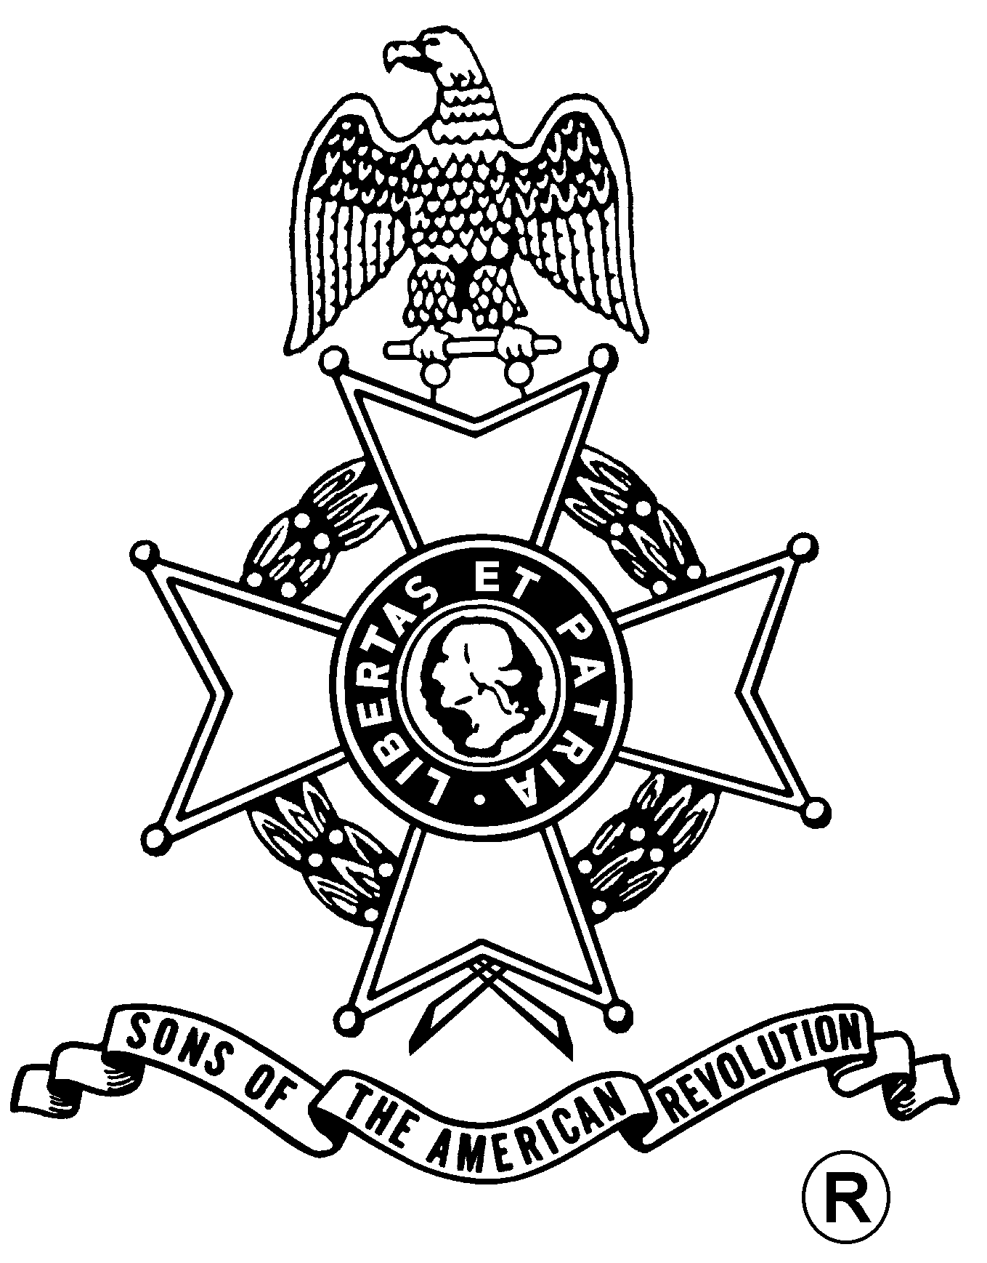
SONS OF THE AMERICAN REVOLUTION
BOARD OF MANAGERS MEETING

Hosted By
Walloomsac Battle Chapter
Saturday, November 17, 2012

Pegasus Restaurant
10885 Route 9W, Coxsackie, NY 12051
(518) 731-9200

Coffee and Danish at 10 a.m., Meeting at 11 a.m.

Lunch Menu
Tossed Green Salad, Rolls and Butter, Chicken Marsala w/ Pasta; Baked Scrod or
Roast Beef both with Mashed Potatoes and Gravy & a Veggie. Dessert & Coffee/Tea/Milk

Total Price $18.00; $5.00 Non-Dining Charge

RSVP by November 13
with check payable to the Walloomsac Battle Chapter SAR

Mail To:
Duane Booth, Treasurer, Walloomsac Battle Chapter, SAR, PO Box 836, New Lebanon, NY 12125-0836 Telephone: (518) 733-0830 Email: Boots42@Fairpoint,net

Directions

From the South: NYS Thruway to Catskill Exit 21, Route 23 east to Route 9W north 8 miles.

From the North: NYS Thruway to Coxsackie Exit 21B, Route 9W south 5 miles.

Visit the ESS Website At:
http://www.ess-sar.org/
For Door to Door Directions
Lodging
At the Coxsackie Exit 21B: Best Western (518-731-8100); Red Carpet Inn (518-731-2722)

(RSVP by November 13)

Reservation Form:

Name: ___________________________________ Choice ($18) __________ Non-Dining ($5): _______

Name: ___________________________________ Choice ($18) __________ Non-Dining ($5): _______

